


GP resource Pack

Support for GP practices on requests for support with housing applications and challenges


Produced by the South London Health and Housing Coalition,
a partnership of community, NHS and local authority leaders
working to co-develop solutions to tackle health and housing challenges

About this resource pack

Patients who are in contact with social housing providers often contact their GP practice for supporting medical information. This can be for many reasons, such as when they are applying for housing, or raising concerns about housing conditions.
This takes up valuable practice time and can be expensive for patients. It is also unnecessary, as patients can access this information themselves, for free, in other ways.
Our aim is to help both practices and patients.
This document provides those working in GP practices with guidance and tools for communicating with, and supporting, patients who want medical information in connection with housing.

How has this been produced?
The resource pack has been produced by the South London Health and Housing Coalition – a partnership of community, NHS and local authority leaders working to co-develop solutions to tackle health and housing challenges.
To find out more, visit www.southlondonlistens.org/areas-of-work/housing
The content has been developed by a working group of NHS, local authority and community representatives, working with leads across all 12 south London boroughs.

General Practice Communications
- Overview
The process of registering for social housing, reporting health challenges, repairs and other issues to social housing landlords (which can be local authorities or housing providers) has moved almost exclusively online.
Patients often approach their GP surgeries with requests for medical letters as self-reporting on their health issues and vulnerabilities can have an impact on how they are assessed by social housing providers.
These requests may come from people who:
- are homeless and/or applying for social housing support the first time
- wish to report recent changes in their health
- wish to report how their current home is impacting their health
- wish to detail how and why their current home is unsuitable for their own/their family’s circumstances
As writing housing letters is not part of contracted core GP services, there is often a charge to the patient. These charges can be very difficult for many people.
Patients do not need specially written letters to report health issues to housing providers. We ask General Practice colleagues to support patients with resources that are available for free; a summary from medical records and/or any other medical letters/reports from healthcare professionals that already exist on their medical records, for example. These documents will meet patients’ needs in these circumstances. In some cases, should further medical information be required a Local Authority may contact a patient’s GP practice to request further information.
Not only is there no additional benefit in patients paying for GP letters, but processing these requests also has a direct impact on primary care resources.
It is important that patients understand how to report health challenges to housing providers, and that we support them to do so in ways that are effective, inclusive and fair e.g via accessing the NHS App.

- Guidance
All social housing providers have processes for people to report health challenges relating to their housing.

Patients should be advised to contact their housing provider to find out how to report any medical concerns. They will usually have to complete a form, either on paper or online.

Common examples of these forms are:
  - reporting homelessness
  - registering for social housing
  - housing medical forms
  - reporting overcrowding and
  - applying to join a housing transfer list.
Patients are often required to provide evidence of health challenges and vulnerabilities they report to housing providers. If the patient does not have copies of existing medical reports or a medical summary, these can be obtained through the NHS app.. Patients can then submit the information along with their application, so that they are appropriately assessed.

Some patients may request additional support with completing housing forms and collating medical evidence. Where possible, please refer people to the social prescriber or care coordinator at the surgery, or signpost to a local community-based service to support them.

- Key materials
The following materials have been produced to support clear communications of the content above.
- Text message response to enquiry
Dear X,
You have asked for a GP letter to report your health challenges to your housing provider. You do not need a GP letter for this.
You can use existing medical letters and a medical summary from your health records. You can get this information, for free:
- Log into the NHS app and go to the documents section
- You can get support with this from (insert link to local support option)
Then you can give this information to your housing provider along with your application, so they have what they need to process your application.
- Email response to enquiry
Dear X,
You have requested a GP letter to report your health challenges to your housing provider. You do not need a GP letter for this.
You can use existing medical letters and a medical summary from your health records. You can get this information, for free:
- Log into the NHS app and accessing the documents section

- You can get support with this from (insert link to local support option)
- Then you can give this information to your housing provider along with your application, so they have what they need to process your application.
Kind regards,
X GP Surgery
- Poster to display in your GP practice

For any more information on this resource pack and the materials provided, please contact info@southlondonlistens.org and please put ‘GP resource pack’ in the subject of your email.

Best practice examples of infographics
to explain the guidance
Created by Lewisham Council

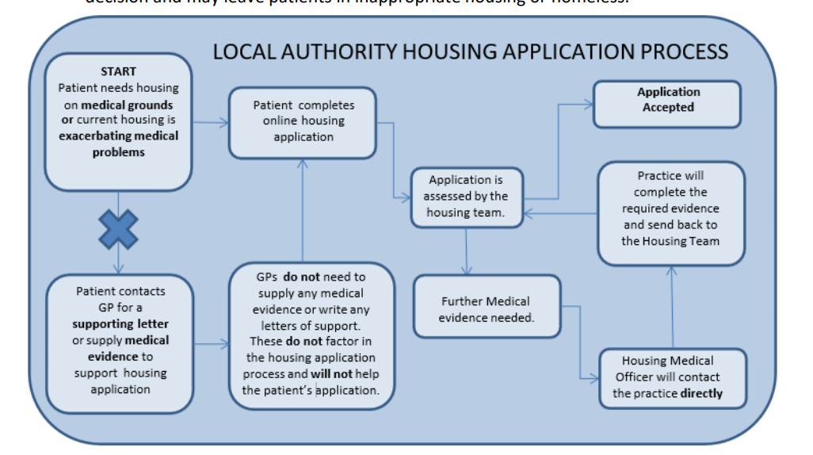
Created by Southwark Council

